

TEMENOS T24

User Guide

Table of Contents

Add Contacts Widget Button <Code>

Introduction 3

Preface 3

Overview 3

Prerequisites 3

Assumptions 3

Getting Started 3

Creating the Add Contacts Widget Button 3

Executing the Add Contacts Widget Button 4

# 

# Introduction

## Preface

This User Guide is intended for Developers and provides the step by step instructions for adding and using the Add Contact Widget button to add or update a contact in the user’s contacts database.

## Overview

The Add Contact widget enables banks to use a button on the screen, for adding their own Call Centre numbers to the contacts. It is also possible to add more than one number, email addresses, URLs and notes to the contact.

## Prerequisites

Distributed with the product. Therefore there are no special installation requirements.

## Assumptions

It is assumed that you are familiar with the edgeConnect Editors and have working knowledge on edgeConnect.

# Getting Started

First, you need to create the Add Contacts Widget button and then check how it works.

## Creating the Add Contacts Widget Button

To create the Add Contacts button:

1. Create a data structure in the **DataStore** **Editor**, to populate with the contact details.
2. Populate the data structure – this could either be rules in the project or through an integration component retrieving the values.
3. Create a button in the **Process Editor** – this will be the element that the user clicks to add the contact. You can add rules under the button within the widgets settings.

You can choose to execute these rules after the contact is created.

1. In the **Presentation Editor**, double-click on **Appearance** and select the **Button** tab.
2. Select **Display Type** -> **com.temenos.widgets.hybrid.contacts.addContact**
3. Within the **Widget Details** tab, you have to set up the widget settings.

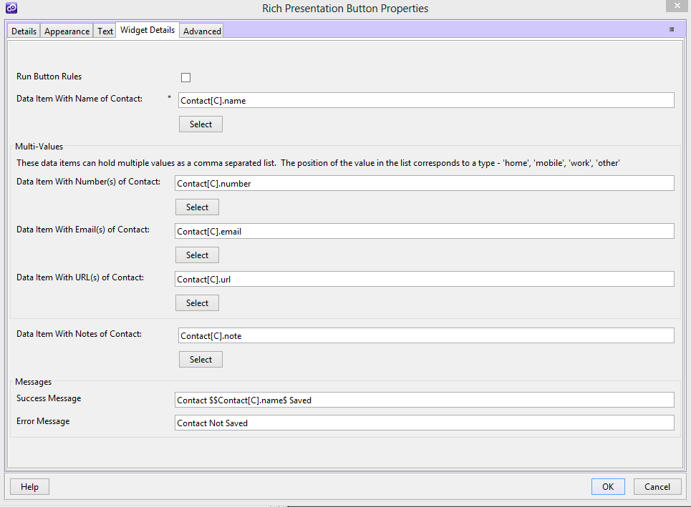

The first checkbox which is **Run Button Rules**, controls the execution of button rules (whether executed or not), after the contact is added.

1. The fields let the users choose the data items that store the contact information. Some of these numbers, emails and URLs can store multiple values as a comma separated list. The order of these is stored in the contact as ‘home’, ‘mobile’, ‘work’, and ‘other’.
2. Finally, you can add messages, which get displayed like Notes, if the contact is successfully created.

## Executing the Add Contacts Widget Button

When the button is generated, the standard click handler is removed and replaced by a new event handler. This checks to see if the contact already exists or if it is new. If it exists, it is deleted. The new contact is then added, and if this is successful, the success message is displayed (if defined). If there is a problem, the error message is displayed (if defined). If the contact was saved successfully, and the developer chose for the rules to be run, the script would have been attached to the button and the rules are executed.

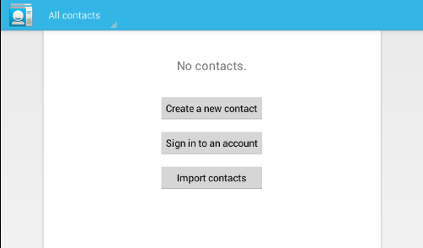

In this example, the button that uses this widget is shown as the ‘Save’ button. It is not necessary to display the fields on the page.

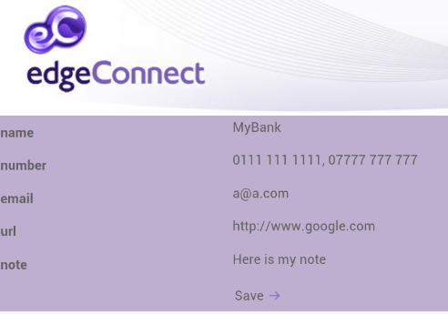

Clicking **Save**, results in the following notification.

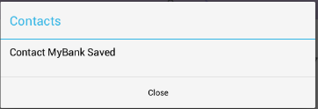

The contact is created and displayed.

